Food Assistance Advisory Committee Meeting
January 26, 2022

Michelle Douglas, Chair, asked those on the call to introduce themselves, their organization, and their hope for 2022.

Present:
Michelle Douglas, EFN, Grateful for support from community;
Mallorie Shellmer, WSDA-Food assistance, Increased flexibility and simplification on projects;
Emily Penna, MPC, take more baths and relax;
Aaron Czyzewski, Food Lifeline, long stretches of beautiful weather;
David Uhl, Feeding Washington, expecting second child;
Andrea Blue, MADF & Eloise’s Cooking Pot, Hoping for more time;
Amelia Paul, Feeding Washington, Needs more help, more staff;
Britany Meiklen, Chelan Douglas CAC, more self-care and healthier 2022;
Jeff Mathias, BMAC, never see James’s background in my warehouse - more order!
Cecilia Chavez, Toppenish Food Bank, get rid of Covid so she can spend more time with family and friends, and open food banks;
Emily Straw, Clark County Food Bank, having a baby! Get progress on new building;
Amber Whitney, Renton Salvation Army, Hoping for all around health;
Jen Muzia, Ballard Food Bank, hope for “normal” again and more in person time;
Stevie Watson, River City Youth Ops, Spokane, all programs are funded, working for a more connected food system;
Nikki Lloyd, Snoqualmie Valley Food Bank, expecting third boy and for health in March;
Peny Archer, Community Services of Moses Lake, serves Grant, Adams, Lincoln and Yakima Counties, economy improves and food banks are not needed;
Sherry Vokoun, NEW Hunger Coalition, lost ED and her hope is to hire a new ED and plan to continue Farm to Food Pantry work;
Bob Mark, Upper Valley MEND, Leavenworth, clearer vision, predictability and new home;
Heidi Cobun, WSDA, in Clark County health and more sleep;
Kim Eads, WSDA Food Assistance Program Manager, Continue perseverance and possibilities, more strategic future;
Kyle Merslich, WSDA, see where dust settles and where things land in the “new normal”;
James Scovel, WSDA, inspire order;
Nichole Garden, WSDA, balance and perseverance
Lisa White, WSDA, Increased staffing for program.
Kira White, Highline College Hub, healthier year;
Lindsey Robinson, WSDA, more ease and focused streamline progress;
Erin Keeler, WSDA, growing team and self-care
Trish Twomey, WFC, Progress and self-care

Michelle summed up the hopes for 2022 as balance, more time and self-care.

II. Approval of minutes
August 24th 2021 meeting minutes
Andrea Blue moved that the minutes be approved. Cecilia Chavez seconded the motion. No opposition.

III. WSDA update - Kim Eads - A variety of slides (see attached) touching on a variety of topics.

TEFAP Ordering Subcommittee Update:
James reviewed a slide on Canceled TFAP loads (2011-2022). WSDA has ordered 567 trucks for 2022; 88 have been cancelled. 15% of all loads from 2011 - 2022. 2020 has the most canceled loads due to COVID (24%), plus production and shipping issues due to COVID.
What causes cancellation? Due to higher prices, they have met a specific dollar amount and in turn will need to cancel.
- Fruit and Vegetables Orders - all entitlement vegetables for 2023. The Food Ordering work group will prioritize their preferences.
- To join the Food Ordering Work Group; send James an email, jscovel@agr.wa.gov
- If you receive direct shipments of TEFAP you must receipt those loads in WBSCM within 48 hours (USDA requirement). However, it is not a requirement for indirect TEFAP loads from NWH, FLL or 2nd Harvest. If you have questions, contact James.
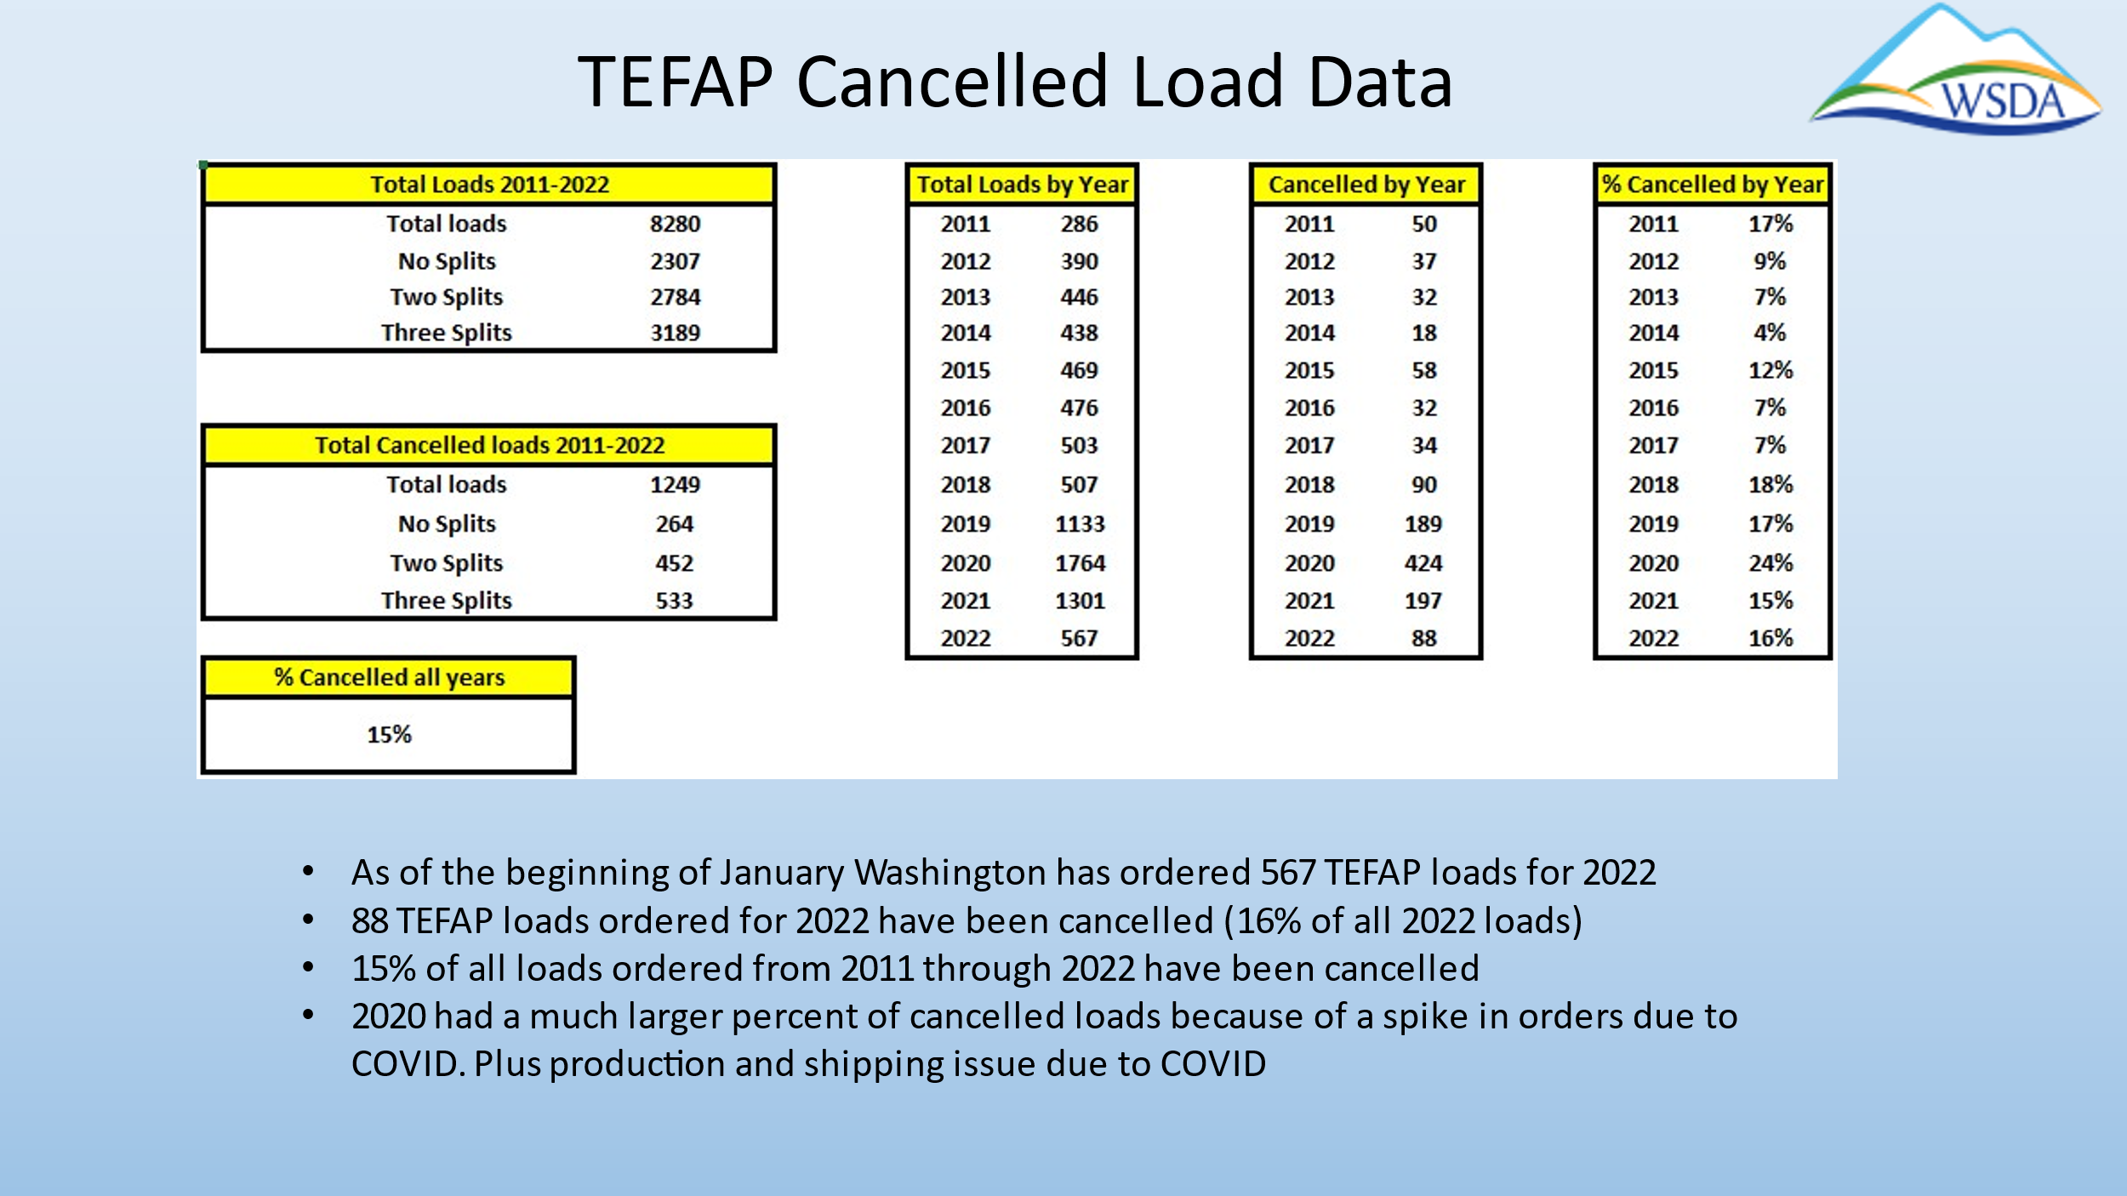
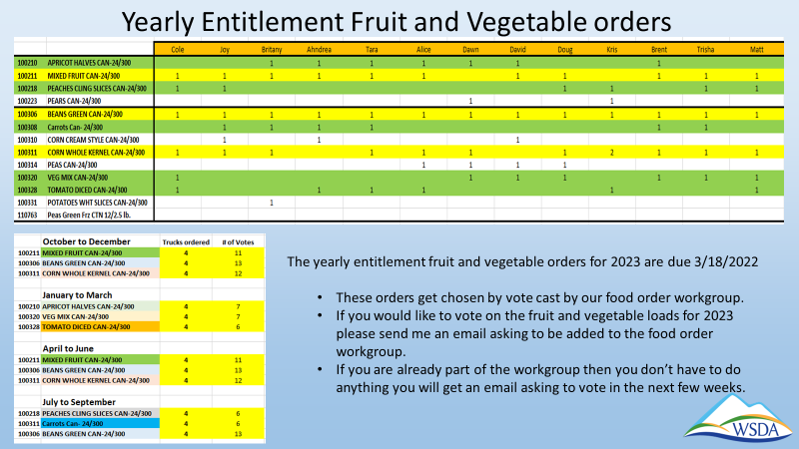

Flexible Funding Grants - Lindsey Robinson
Lindsey reported that all awardees have been selected and WSDA is now preparing for year two. The name of this program will change to “Resiliency Grants and Initiatives”. Funding priorities of this program are to address the impacts of COVID on the hunger relief network and particularly support BIPOC and underserved communities. $16 M in applications were received in the first round of grant awards due to broad outreach and out-of-network agency participation. There is a variety of project sizes and program scopes that will address a broad range of needs across the state. In total, 100 contracts were awarded.
The list of all awarded organizations was shared, but the list is private as of the date of this meeting (while some contracts are finalized). More communication to come regarding connecting so-called “out-of-network” organizations with agencies already participating in FA programs, for enhanced regional partnerships in the future.
Year 2 planning is underway. Wins - Strong Advisory Subcommittee, strong BIPOC applications, streamlined application process, HAH admin partnership, weekly info sessions. Opportunities – desire more rural/remote representation, more regional collaboration, improved data collection and selection processes. May have additional administrative partners.
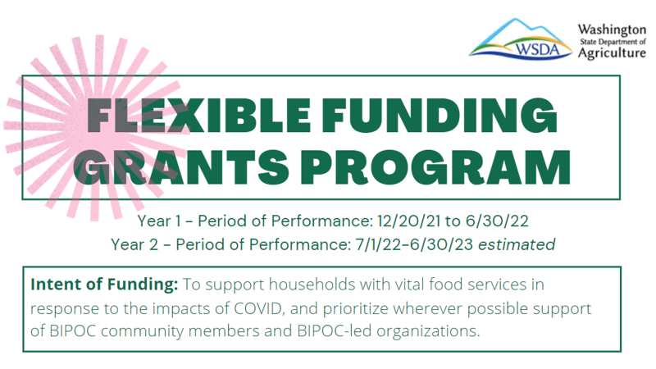
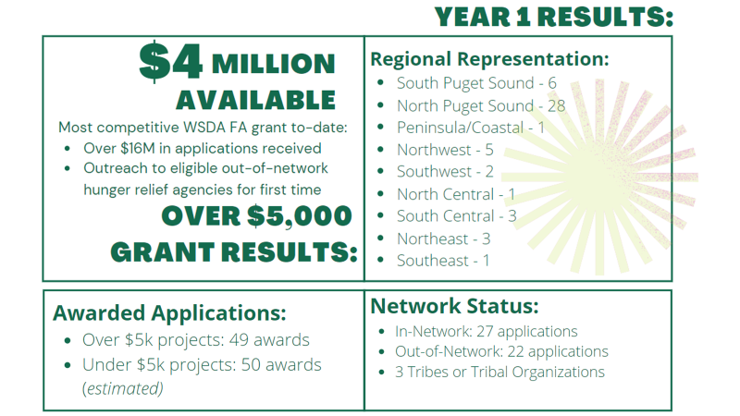
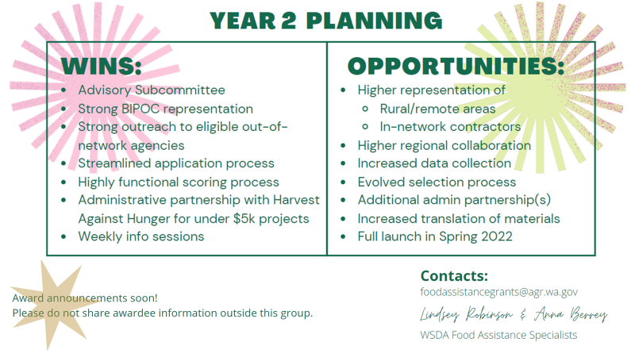
WSDA Food Assistance Grant forecast (See slide)
TEFAP Reach and Resiliency Grant upcoming for WSDA to apply for.
WSDA FA FFG (now the Resiliency initiatives and Grants Program: application launch in April 2022. Amount is pending SFY 23 Supplemental Budget. Updates can be found here.

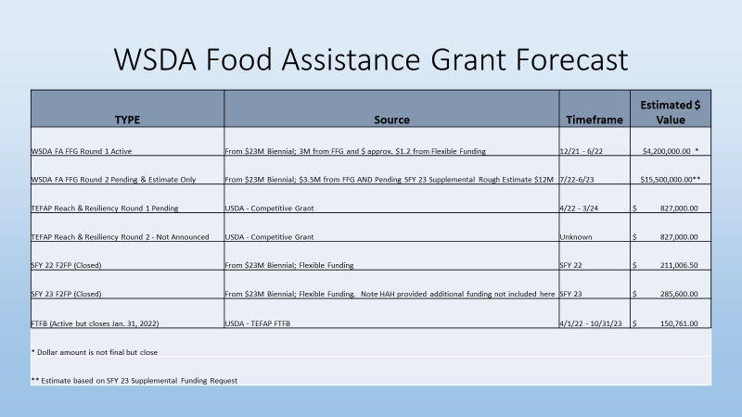

TEFAP funding forecast
General funding updates and TEFAP Commodity Forecast -
TEFAP in FFY 23 funding is low. Expect funding reductions in operational funding contracts.
TEFAP Risk Assessment completed by March 21st.
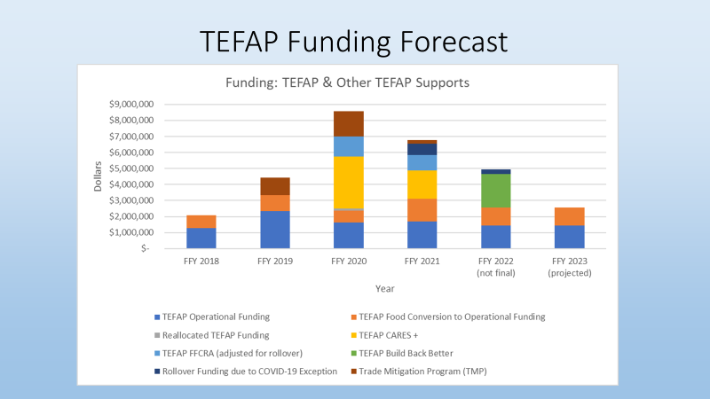

Decreasing client access barriers -
USDA may deny the increase to 400% of the poverty rate for TEFAP client income eligibility guidelines, or they may put a time limit on it. Their usual limit is 250%. Income Guidelines for Washington State are currently being reviewed by USDA.

Funding -
Kim shared a slide on different funding sources and how they were utilized. WSDA needs additional funding and wants to get everyone’s feedback. If there is time later in the meeting Kim would like us to address this.

IV. Review Work in Progress:
Subcontractor Resources Task Force - On hold

Statewide Nutrition Policy- Trish
The first draft of the nutrition policy is complete and will be sent out with a survey to Washington Food Coalition members for input, ideas and questions. Identify what type of support members need. Public Health- Seattle King County offered funding to WFC for a contract person to help move this policy along. More details about the nutrition policy can be found in the WFC Quarterly Newsletter in December.

Washington State Hunger Relief Capacity Report - David Bobanick
Shared that they have finalized the capacity report. Full survey and Executive Summary will be available. HAH partnered with WSDA and contracted with U of W and Jenn Tennent to complete the capacity report. Take a look at where we are in a snapshot in time related to COVID. What was your organization doing before and during COVID? Projected Financial impact of capacity needs and recommendations. Looked at region needs across the State. Responses from across the state - David wanted to thank everyone for their participation. Link to the report and its Executive Summary can be found on Harvest Against Hunger‘s website.

Intake Requirements Subcommittee-
In response to COVID-19, the income eligibility guidelines for TEFAP in WA was raised to 400%. It was raised to increase the amount of people who could qualify for the program, however it might not be approved by USDA. No immediate response is needed currently. Once WSDA is notified by USDA they will notify us. The Subcommittee may need to come together to discuss this and strategize. A study done in King County supports why it should be at 400%. Plan to convene a meeting of the Intake Requirements Subcommittee soon. More research needs to happen. New guidelines from WSDA - not limiting those you serve for TEFAP or asking for any ID. Michelle asked if there were any concerns or questions from the group on how this guideline is working.

EFAP New Client Count - Kyle Merslich, WSDA
Possible changes, questions about the quality of data and changes to intake requirements. Should there be changes to how we collect data, and specifically should there be consistency on when (time frame) we consider clients as new and returning, such as State Fiscal Year, or calendar year? Lots of options on how numbers are collected. Should there be more consistency and guidance from WSDA?
- see handout Current requirements and next steps.

Intake Subcommittee: Add Ahndrea Blue, Emily Straw, David Uhl and Amelia Paul to the subcommittee. Link2Feed requirements.

Aaron from Food Lifeline mentioned that there is a group from Seattle meeting regarding TEFAP, product selection, reporting and intake requirements. Kim Schrier has offered to have a listening session related to TEFAP. Contact Aaron if interested in this workgroup.

What kind of support do you need to keep moving forward?
- Snoqualmie Valley Food Bank needs volunteers, staff and space. Guidance on in home test kits. What is the timing on test kits? Need information.
- Trish added that it’s best to check with your local Emergency Operations Center (EOC) for N-95 masks.
- The Governor has committed to having 12 million for masks distributed throughout the state, first through schools, then other community access points. Hope to have food banks be a point of distribution. 2022 Mask Distribution Process (& PPE Order Form + contact information) https://www.doh.wa.gov/AboutUs/ProgramsandServices/EmergencyPreparednessandResponse/PPEBackstop#1
- WSDA has informed the State EOC, through a memo, that masks are needed. Local EOC’s have been alerted about the masks. Try asking them. Currently tests are exhausted. Try local hospital groups too.
- EFN - water is a need especially during the summer and with winter shelters.
- Ahndrea, Eloise Cooking Pot- needs boxes, tape, shrink wrap, grocery bags, PPE, hand sanitizer & masks. Everyone is burnt out.

Kim announced that on Friday at 10 AM there will be a meeting to give input to WSDA on funds requested through the supplemental funds from the legislature.

The Washington Food Coalition in-person conference will be April 21st and 22nd in Wenatchee. Annual conference in September in Bremerton.

Hunger Action Day is February 7th. Please register.

DOH training on new Food Rules and food labeling, next Wednesday.

Contractor’s Call- Feb. 4th 9 a.m.
General call on Feb. 15th at 9 a.m.

