Meeting Minutes for the
Food Advisory Committee Meeting
April 15, 2021 9:00 a.m.
Present: Michelle Douglas (Chair), James Scovel, Kim Eads, Mallorie Shellmer, Erin Kester, Lisa White, Helen McGovern-Pilant, Ken Trainor, Penny Archer, Amelia Paul, Kyle Merslich, Nichole Garden, Kris Van Gasken, Andrea Blue, Dave McKillip, Claire Lane, Kate Ortiz, Stephanie Watson, Lindsey Robinson (Secretary), Robert Coit and Trish Twomey (WFC staff)
Meeting called to order 9:02am. Welcome, hope you’re enjoying the Spring weather! Lindsey R. agreed to act as secretary for the meeting.
Review of last meetings minutes: Motion to accept last meeting’s minutes with no changes.
Motion made by Alan Hamilton. Seconded by Ken Trainor. Motion carried.
WSDA Updates (Kim E.)
Capacity Grants Awards
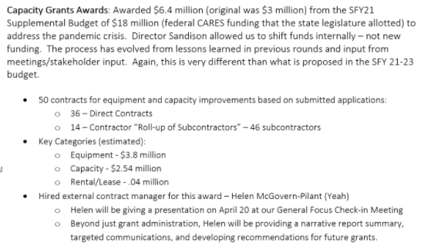
- Note: Helen working on break out lists of awarded projects by congressional district, county, and type of project - to be shared out at future WSDA meeting.
CFAP Boxes Update
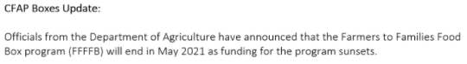
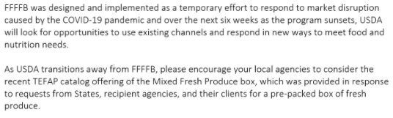
- Note: Hoping to see variations of this program in future and similar, ongoing support.
TEFAP Mixed Produce Fresh Boxes
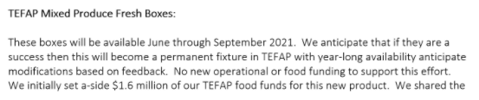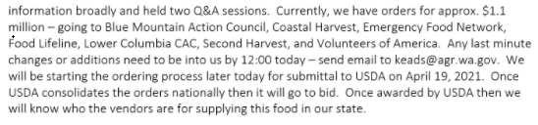
- Notes:
- Boxes have a two local product minimum.
- WSDA shared input with USDA branch in charge of ordering.
- Kim says could be test for adding new, different, local product to TEFAP; expects evolution of TEFAP over next couple years. Hopes all TEFAP contractors will participate but acknowledges unknowns; especially encourages organizations with successful history working with produce. All WA state TEFAP contractors have received information and opportunities to participate.
EFAP Biennium Funding
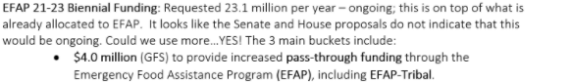
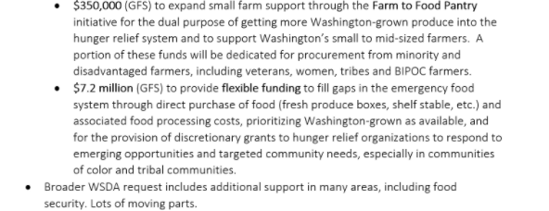
- Notes:
- This request was initiated at beginning of COVID-19 or would have asked for more.
- Any awards are additional to awarded EFAP funding.
- Claire says session ends April 25 and expect final budget proposal next week.
Reviewing Work in Progress
- Subcontractor Resources Task Force on hold, WFC working on resources for future
- Upcoming WFC Trainings:
  - Food Bank Certification Course – May 19th & 20th
  - Food Safety Training with Susan Shelton, DOH – April 28th 2pm
  - Workplace Safety Training(s) this Spring
- Notes:
  - 100 people signed up for March’s Food Bank Certification Course, 72 took exam.
  - Susan S. did initial Food Safety Training as part of FB Cert Course; so many questions about new food rules and FB operations that offered separate training. Will be recorded and materials provided.
  - WFC evaluating what next annual conference (Sept 29-Oct 1) looks like. Sent survey for feedback (in-person vs. virtual), will be announced at today’s Board Meeting today. Trainings will be provided either way.
TEFAP Update & Discussion (James S.)
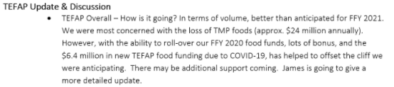
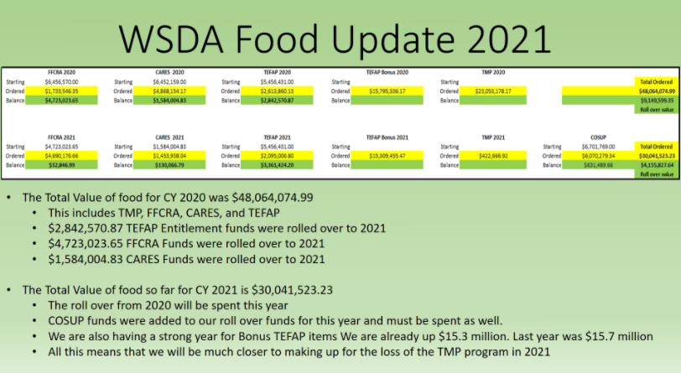
- Notes:
- Expected TEFAP “cliff” (due to loss of TMP - $24M) has been largely mitigated because several funding buckets rolled over to 2021.
- $30M spent on TEFAP this CY so far. Will be closer to $48M by end of CY, more than previously thought, shaping up as good year.
- Product Review:
  - Good mix coming. Variety of fresh/frozen foods and canned protein; lesser quantities of split peas and beans.
  - Request for feedback on pouched chicken (lesser quality than hoped) will pass on.
  - Only produce in July is grapes.
  - Largest truck order in July, tapers off considerably after that.
  - Discussion of preferred milk size (gallon or quart).
  - Milk not listed July – Oct but will be ordered soon.
  - Less fresh and frozen this year because TMP was nearly 50% fresh/frozen, so closer to traditional mix of 20% fresh/frozen monthly (current CY projections are 26% fresh, 9% frozen, 66% dry). Ken and Michelle say they distribute apples/grapes by the case.
- More TEFAP info at WSDA contractor call tomorrow (Michelle highly recommends these meetings). Reach out to Trish for meeting info.
- James contact info jscovel@agr.wa.gov.
- Monthly TEFAP product lists at bottom of notes.
Intake Requirements Subcommittee report out: (Michelle D.)
- Big change for USDA to make recommendation and advocate for removing barriers. Subcommittee discussed lobbying/advocating to USDA further reduction of data requirements (name, address); can we take more unified approach, highlight our values and advocate for removing barriers; discussed possible next steps, including food pantry compliance reviews.
- Discussion opened for feedback from this group.
  - Trish heard concerns re: removal of TEFAP boundaries, fear of service duplication. Claire says hunger at unprecedented rates and should message our jobs are fighting hunger, not policing duplication. Michelle mentions intent vs. impact, requiring documents results in undocumented/ vulnerable populations not seeking help.
  - Alan H. says fan of reduced data collection, faster service removes another barrier (slow service is a barrier). Wants to know if there would be negative repercussion.
  - Andrea B. says in full support of not asking for unneeded information and believes there should not be an exchange for food; knows people go to multiple pantries to meet their needs and says is valid.
  - Ken T. says intake is to distinguish between new and returning clients only.
  - Claire L. says difference between data for eligibility and data for program evaluation. E.g., are we reaching Latinx communities? Serving seniors adequately? Need more outreach in X city or community?
    - Name & address = barrier to eligibility.
    - Zip code, household ages, race/ethnicity = program evaluation
  - Stephanie W says data tracked should be meaningful to health outcomes, solving food insecurity. Less paperwork means more access.
- Michelle asks that subcommittee do a bit more work and make next step recommendations.
- Kim can provide update with opportunity for discussion at WSDA contractor meeting tomorrow, goal to include information to EFAP Spring meeting agendas.
Statewide Nutrition Policy – create subgroup
- Trish: Public Health KC approached WFC to discuss nutrition standards. A lot happening on national level and think topic important for coalition to take on.
- Kate Ortiz, King County Public Health:
  - Has worked for 5 years with NWH to develop nutrition policies.
  - Nutrition policy is formalized statement of what kinds of food you serve and what you limit, and HOW you provide service.
  - Policy implementation can:
    - Acknowledge nutrition matters for your organization, meeting client needs matters (not just providing poundage of food).
    - Guide procurement decisions and support consistent decision-making across your organization.
    - Help with staff turnover to maintain organizational values over time.
    - Move the work of emergency food away from charity to health equity, to ensure service meets the needs of the customers.
    - Capture broader commitments and address the “how” of service, including intake, respect, and customer interactions.
    - Be a communication tool for external (donors) and internal partners (customers). Tell donors what you accept and don’t accept.
    - Record the hard work already happening, because often informal policies in place that aren’t communicated broadly.
  - Supporting nutrition is particularly possible right now with additional funding.
  - Coming together with unified voice at state level will help with advocacy and communicating to larger donors.
- Dave M says great idea to implement on state level, our policy has helped with fundraising, community partnerships, improving client health outcomes. Can be difficult to acquire nutritious food, so unified voice will be helpful.
- Mallorie S. says a statewide policy could help Food Ordering Workgroup efforts.
- If interested in joining Statewide Nutrition Policy Subgroup, reach out to Trish.
Good of the Order:
- Robert brought forward drafted letter (below) and proposal to provide feedback to WSDA on past grant cycles (anyone with experience) for future improvement. Not intended as criticism but observation. Goal to compile feedback and send as one email. Interested in collecting feedback from this group to present to WSDA.
  - Kim says that feedback is actively collected and acted upon, let’s work together. Alan agrees.
  - If interested in being part of this subgroup, let Trish know.
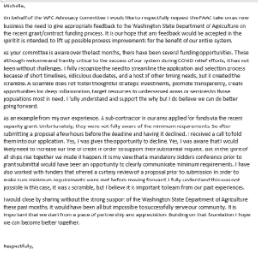
New subcommittees: Statewide Nutrition Policy, Feedback for WSDA
Motion to end meeting. Carried.
