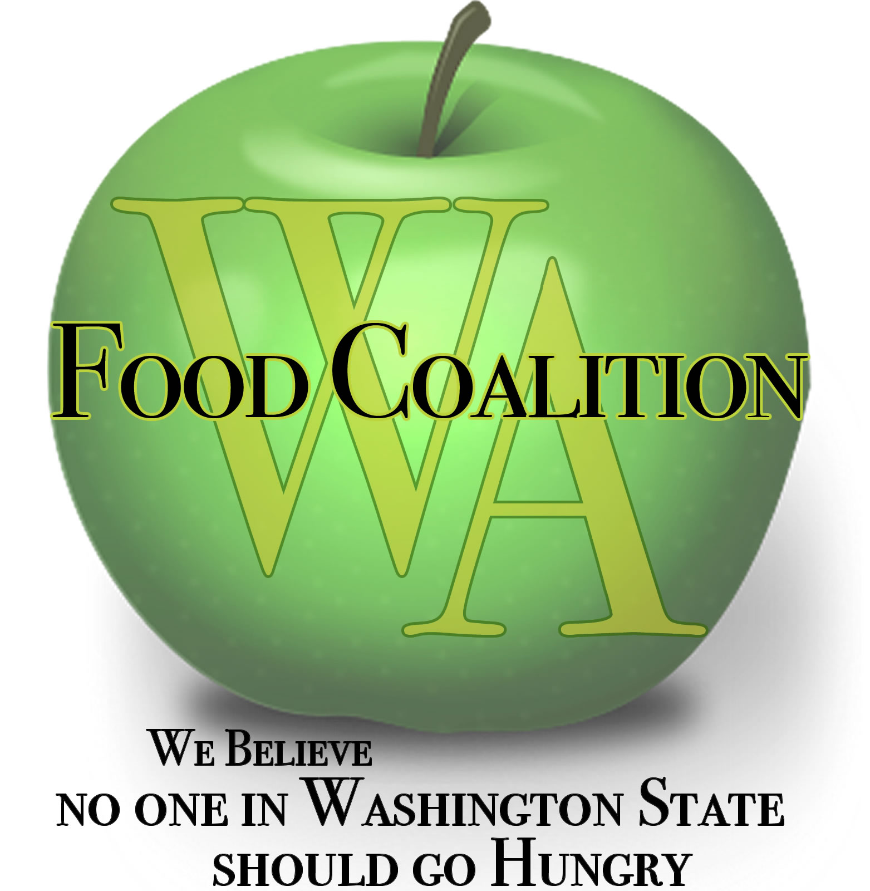
Washington Food Coalition
www.wafoodcoalition.org
PO Box 95752
Seattle, WA 98145
phone: 206.729.0501
fax: 206.729.0504
info@wafoodcoalition.org

Food Assistance Advisory Committee Mtg
July 19th, 2019 9:30am-10:50am

Location:
Northwest Harvest’s New Food Bank
1915 4th Avenue S., Seattle, WA 98134
Please join my meeting from your computer, tablet or smartphone.
https://global.gotomeeting.com/join/152548389
You can also dial in using your phone.
United States: +1 (571) 317-3122
Access Code: 152-548-389
Joining from a video-conferencing room or system?
Depending on your device, dial:
152548389@67.217.95.2 or 67.217.95.2##152548389
New to GoToMeeting? Get the app now: https://global.gotomeeting.com/install/152548389

9:30 Welcome and Intros

9:35 Approval of Minutes from April 19th

9:40 Review work in progress and status
Civil Rights Task Force update
Subcontractor Resources Task Force update

9:55 WSDA Updates

10:15 Legislative Updates

10:25 Discussion topics
Food procurement policy changes
United Way Funding changes
Food Safety and Retail Food Code changes
10:45 Anything Else for the Good of the Order?

10:50 Close

NEXT MEETINGS – SAVE THE DATE:
Monday Sept 23rd, 2019

NOTE: If you are participating remotely in the Board meeting, see agenda for GoToMeeting info

